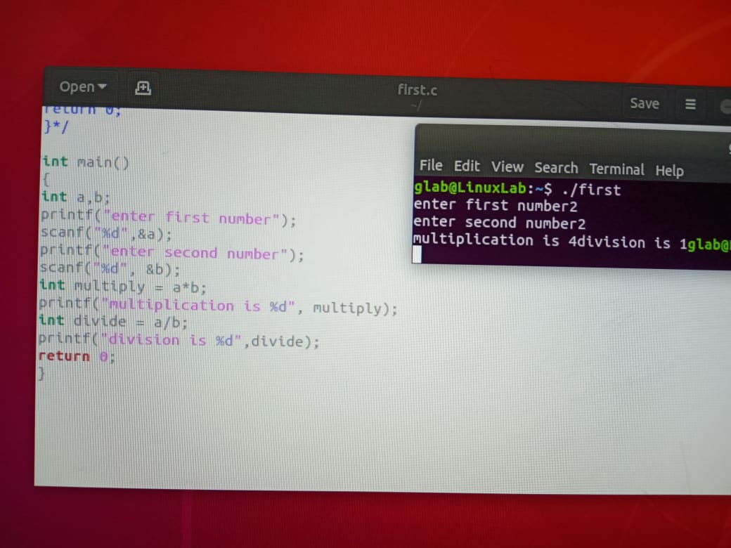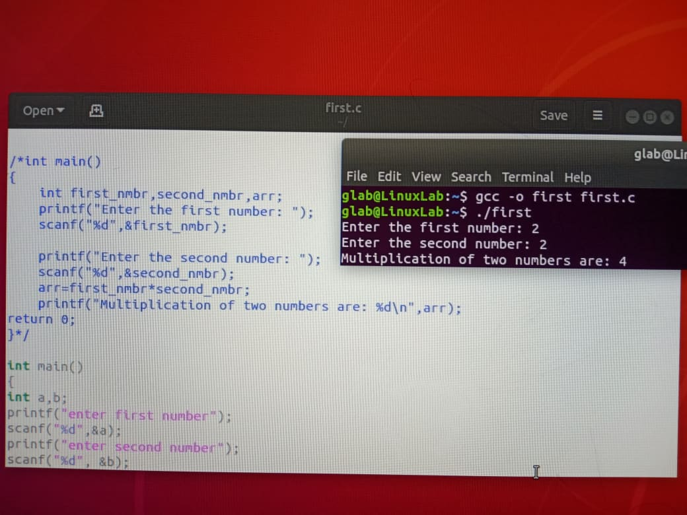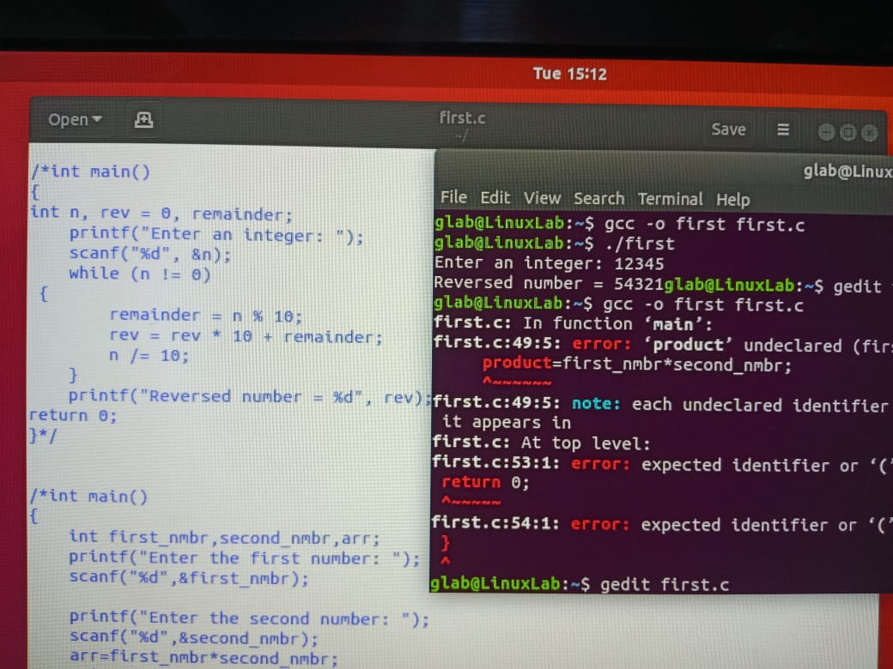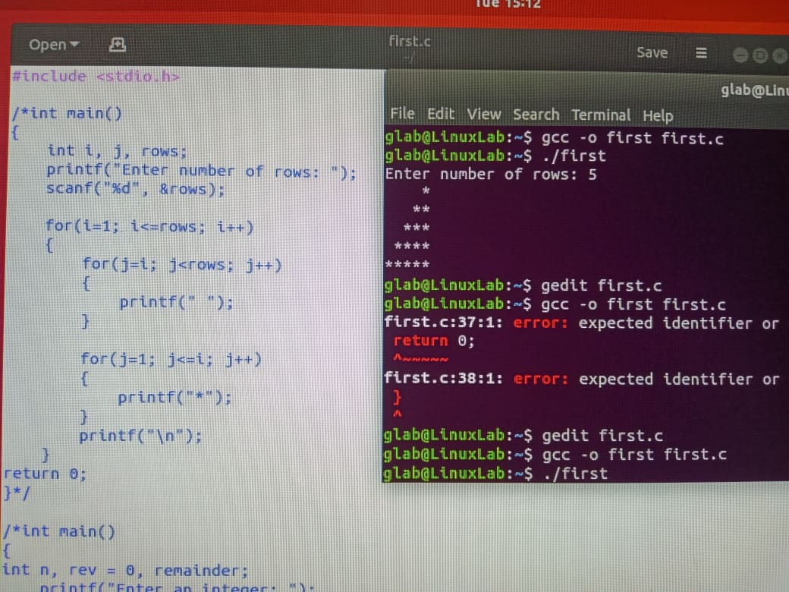

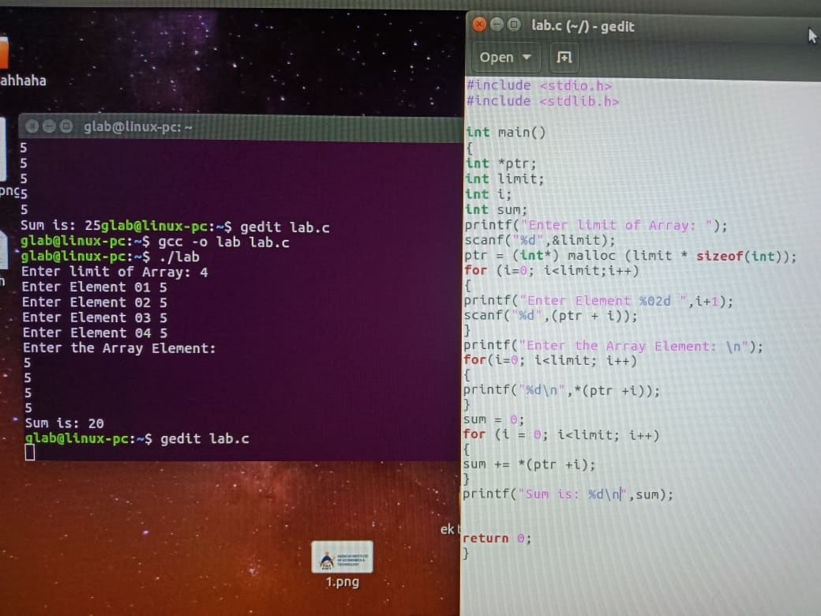

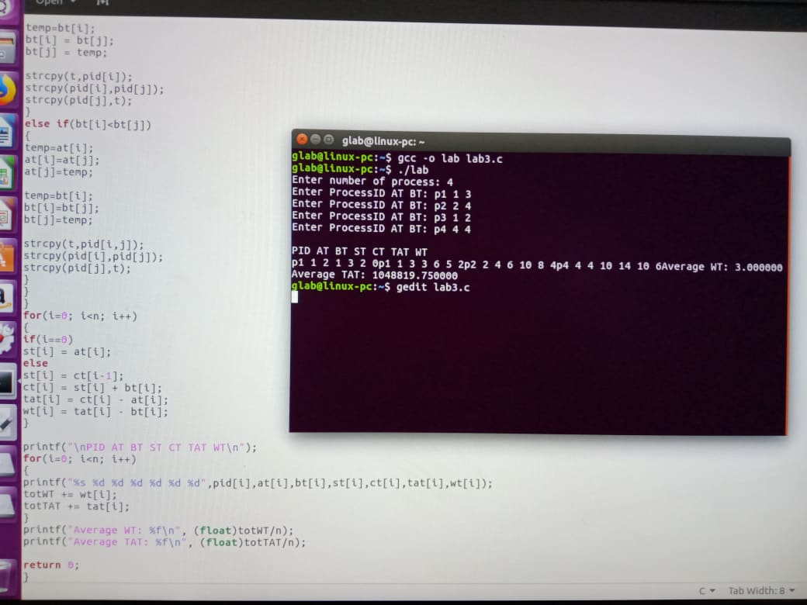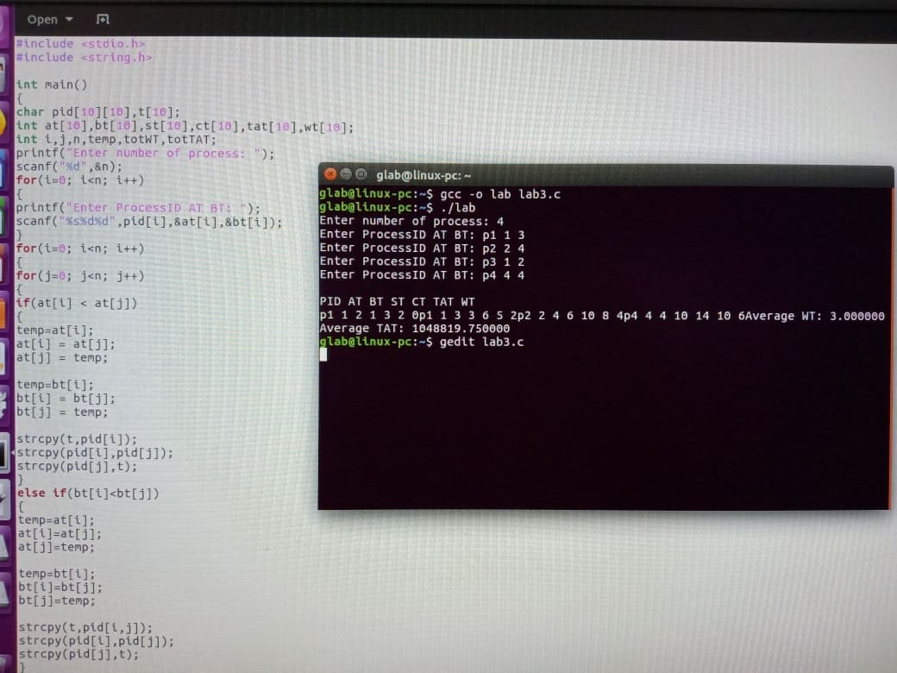

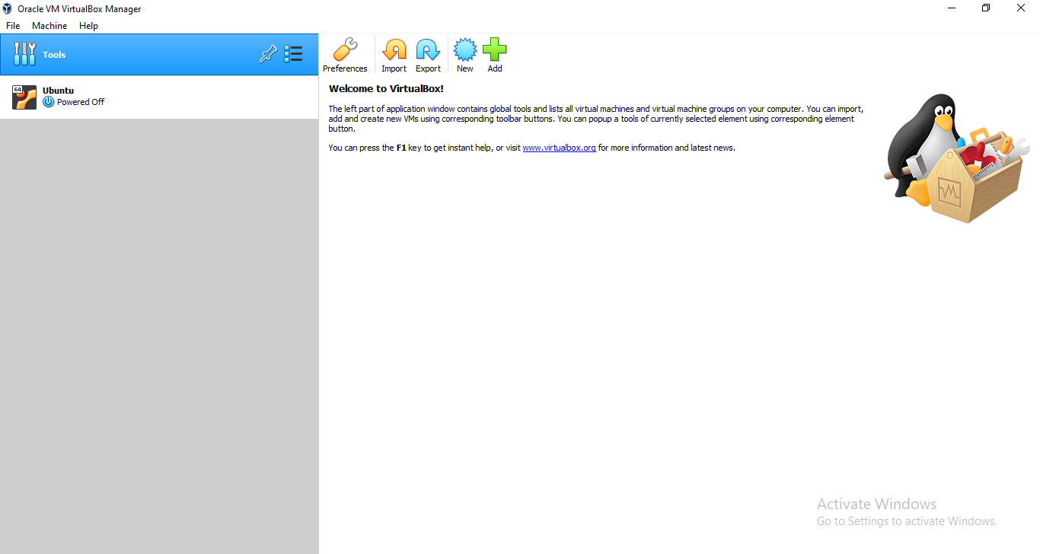

Step # 01

Installation Of Virtual Box Manager

Step # 02

Now Clicking on the “New” button on the top in blue color:

After clicking on the blue “new” button a new window will appear enter the name “Ubuntu” and click on next:

Step # 03

After clicking on the next button another window will pop up asking about the memory size (for main memory) set the memory size according to your system and then click on next button:

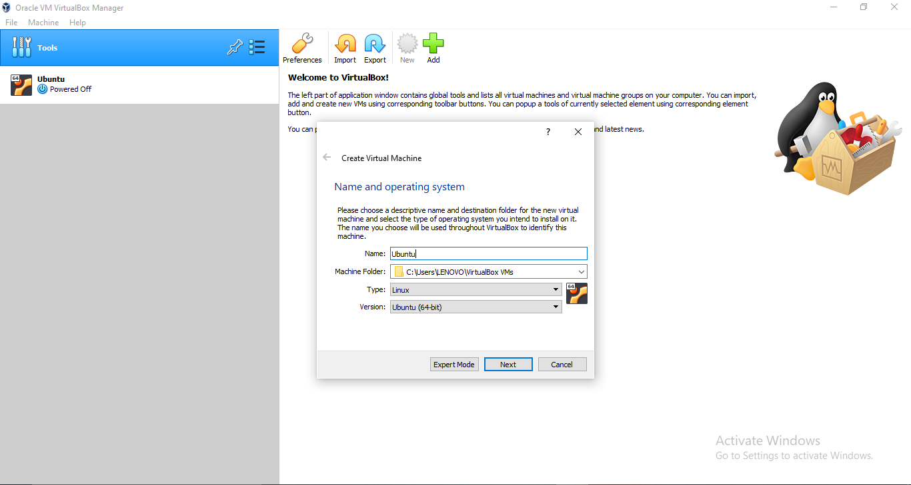

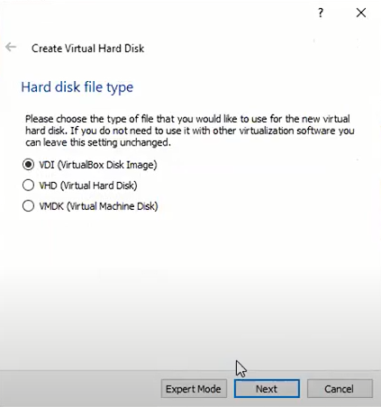

Step # 04

After that another window will pop up with the name of “Hard Disk” with 3 options you have to check the middle option of “Create a virtual hard disk now” and click on the create button:

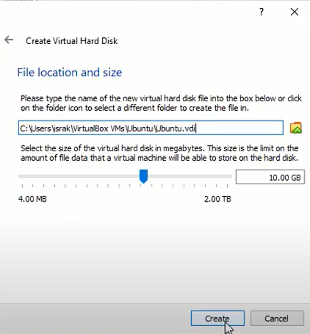

Step # 05

Another window will pop up after that with name of “Hard disk file type” with 3 options again check on the first option (VDI) and click next.

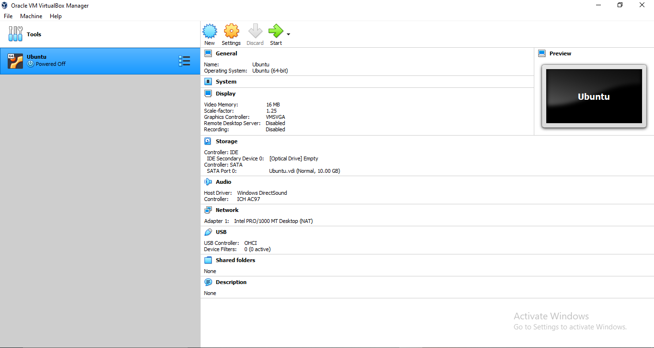

Step # 06

After clicking on the next button another new window will pop up with name of “Storage on physical hard disk” check on the option “Dynamic allocated” and click next.

Step # 07

After this another new window will pop up with the name of file location and size, select the file location where you want to install “Ubuntu” and set the file size of minimum 10GB.

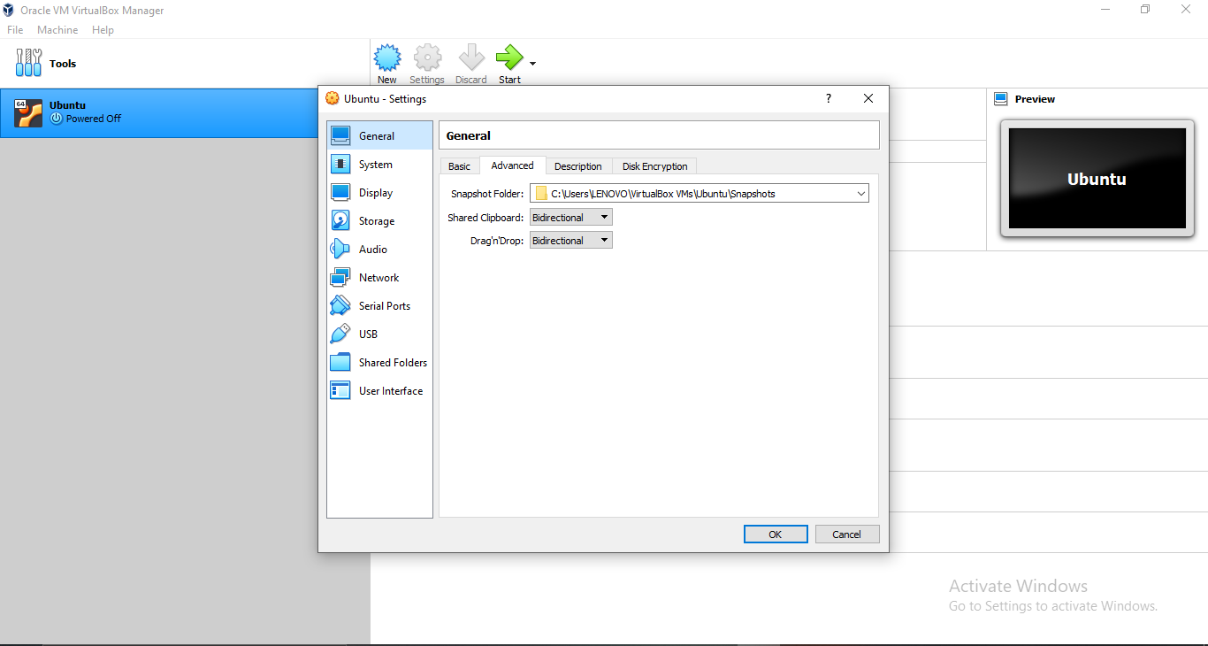

Now do the following steps:

After all these steps on the left “Ubuntu” option will appear

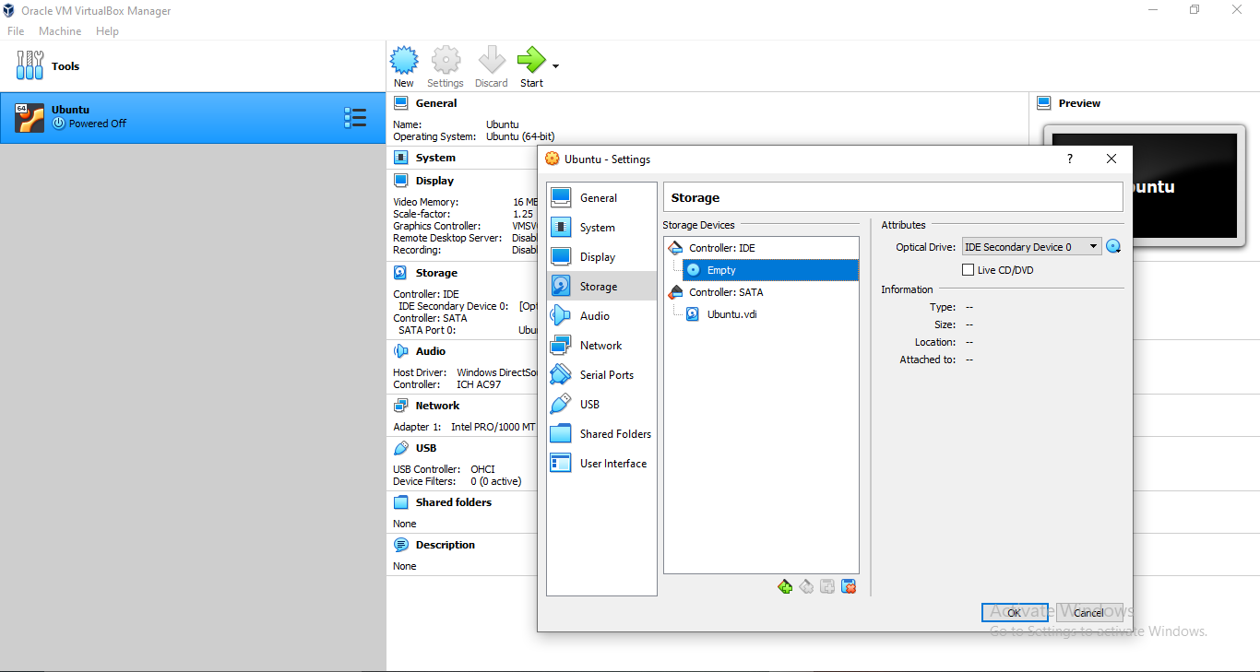

After that go to the storage section click on the blue disk icon on the left and then a another blue disk icon appear on the right click on that icon and select “create a virtual optical disk” a new window will pop up then click on the blue disk icon with a plus on it in the new window and add the setup of Ubuntu where you have downloaded it.

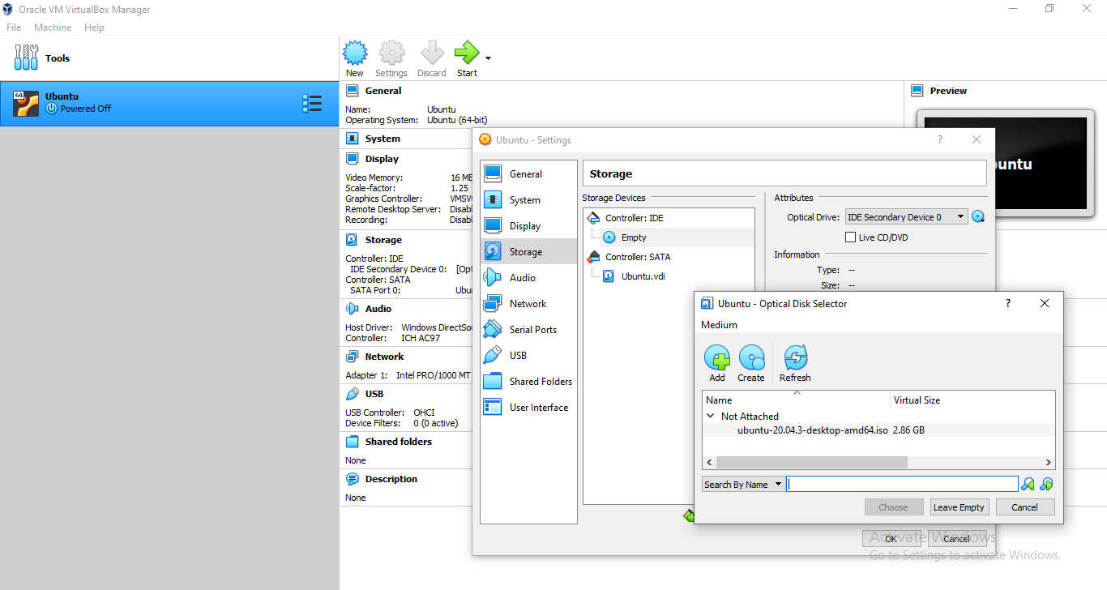

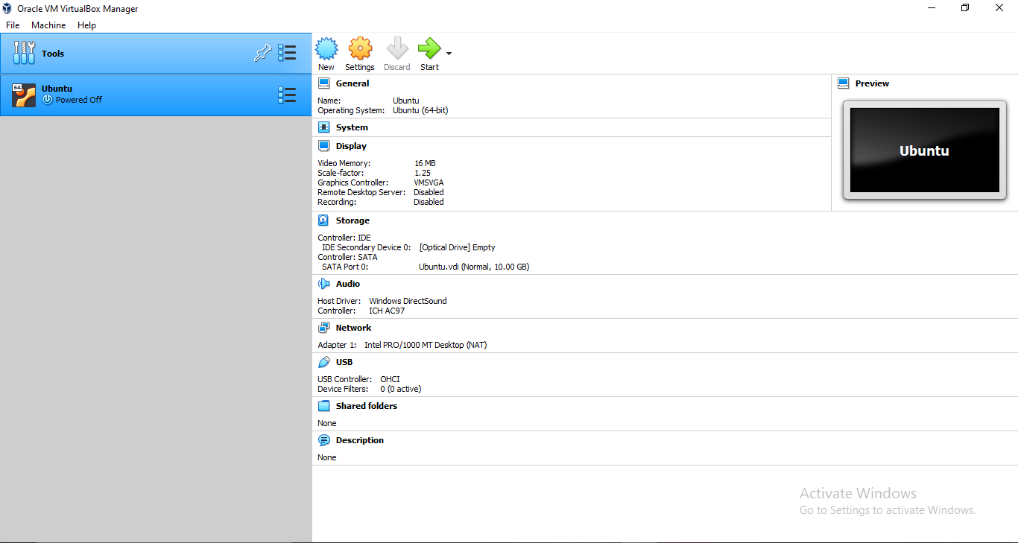

After adding the setup click on the start green arrow button in the base window

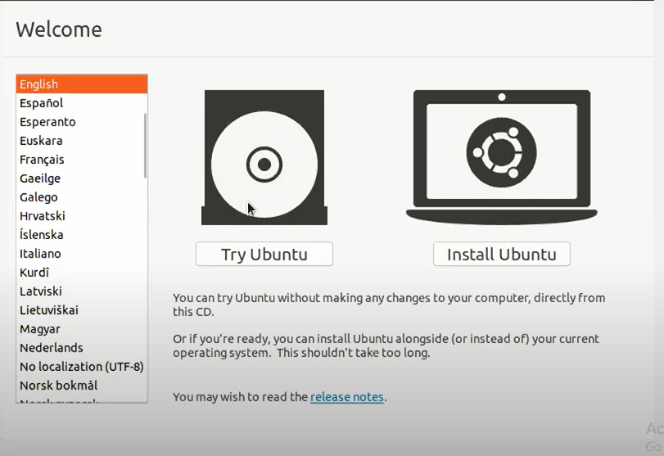

After that the following window will appear click on “Install Ubuntu”

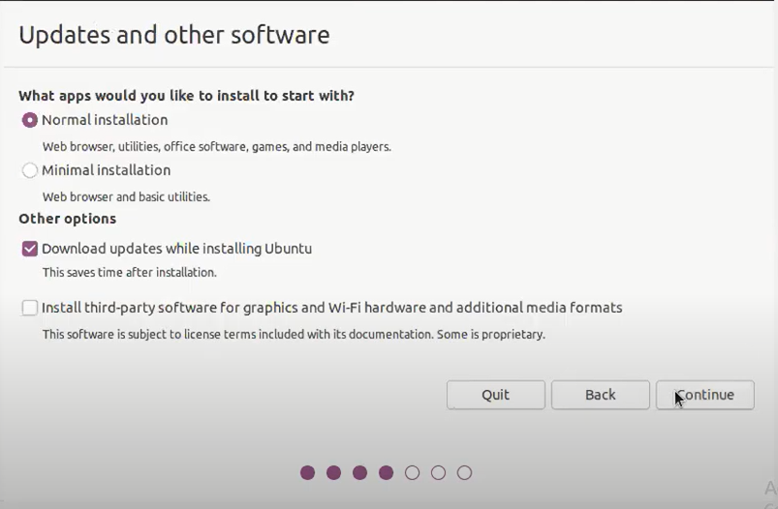

This window will appear of “updates and software” remain the checked options checked and click on continue:

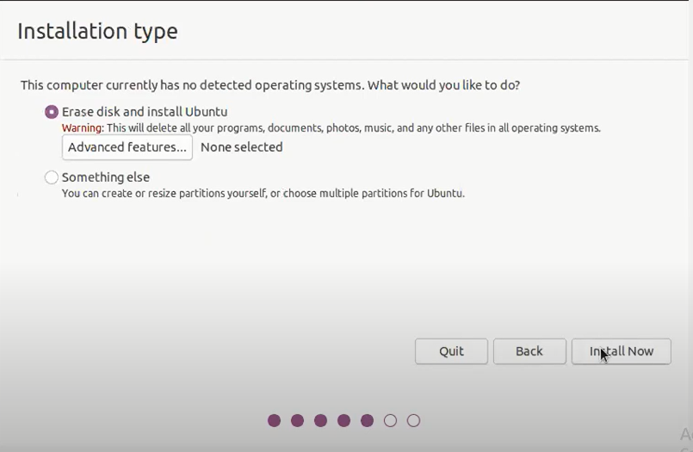

Click on install now in the next window:

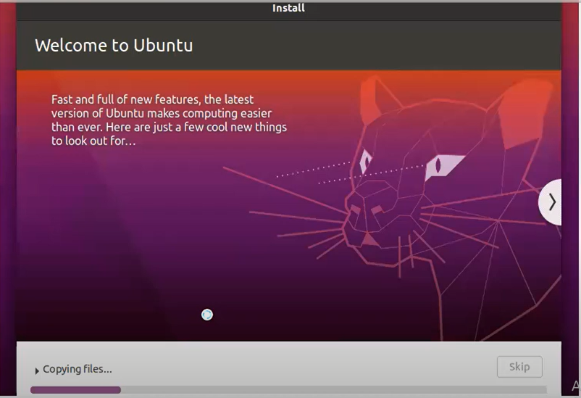

After clicking on install now button it will ask you about your region your username and if you want more security you can add password as well

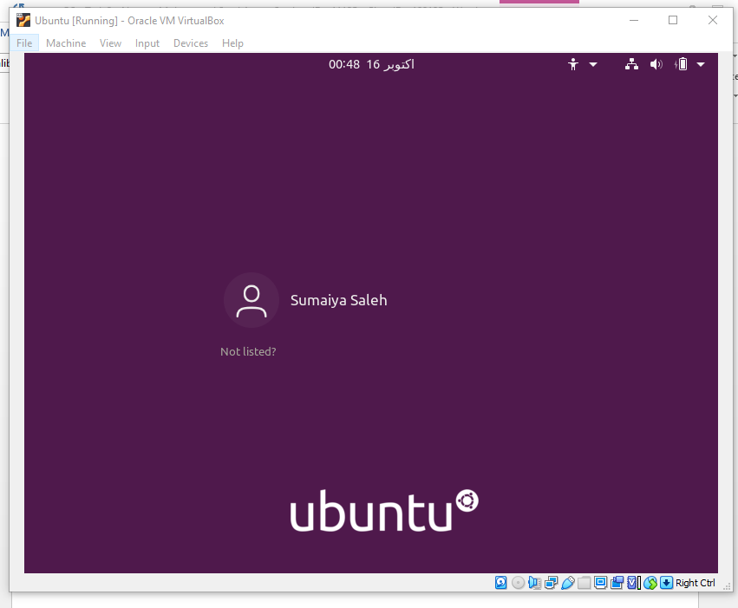

After the completion of installation, a log in page for Ubuntu will appear

